**St Cuthbert’s Hospice – Innovation Roadmap**

Table of Contents

Purpose of this document 3

Overview 3

Target audience 3

Unique selling proposition 3

Appealing to people’s rational and emotional sides 5

Transparency 6

Marketing channels 8

Website suggestions 8

Content marketing 15

Explainer video 16

PPC/paid social advertising 16

6-month marketing roadmap 17

# Purpose of this document

The purpose of this Innovation Roadmap is to lay out how we’d recommend taking your marketing forward.

It includes insights into building your brand and attracting customers, and is focused on actionable steps you can take to help grow your charity and achieve your goals.

Your Innovation Roadmap has also been created with the budget and time you have available to allocate to marketing in mind.

# Overview

# St Cuthbert’s Hospice is a charity based in Durham and Chester-Le-Street that’s been running for 30 years. You provide a number of services to the local community including end of life care, symptom control and pain management, bereavement support and dementia care through a specialist dementia nurse.

As we discussed in our initial meeting, this strategy will focus on guidance on renewing your website and building a brand online.

# Target audience

As we discussed in our initial meeting, it’s crucial to the success of your marketing efforts that you focus them on your specific target audience.

To put it into context, the most likely people to buy the latest iPhone are people who owned the previous four models. If someone already owns 19 cookbooks, they’re more likely to buy their 20th, than someone with no cookbooks is to buy their first.

In your case, the people most likely to donate to your charity are people who already give to other charities. Or people who have a cause close to their hearts. And the people who are the most likely to come to your next fundraising event are the people who came to the last one (as well as people who regularly go to local events in general).

In our initial meeting, you also told us you’ve identified from your own data and experience that most people who donate to you are women. These women often continue to give to St Cuthberts because their mother did.

We therefore recommend that you focus your marketing efforts on the target audience that you’re likely to have the most success with: **local women who already regularly give to charity**.

# Unique selling proposition

Your **unique selling proposition (USP)** is what separates your product or service from the competition.

For example, Amazon Prime’s **USP** is:

Get almost any product delivered to your door tomorrow at one of the best prices on the internet

Spotify’s **USP** is:

Get access to almost every song ever recorded for just £10 a month

And Ford Fiesta’s **USP** is:

An affordable, reliable, and safe hatchback from a brand you can trust

Showcasing your business’s **unique selling proposition** is the foundation of any effective strategy. Without defining what makes your product or service unique in the eyes of your target customers, you won’t be able to craft compelling messages that will make them buy from you.

It’s therefore critical that it’s clarified before you go any further with your marketing efforts.

Furthermore, it’s crucial that you define your **USP** from your target customers’ perspective. Consider what’s important to them – why they would donate to your charity rather than another.

**Concentrate what makes your offer unique from other charities in one or two sentences, as in the examples above.**

Consider this from the person donating’s perspective – what are they concerned about?

As we discussed in our initial meeting, you discussed that what sets you apart from other charities to potential donors is the fact that you’ve been part of the fabric of your local community for 30 years.

# Appealing to people’s rational and emotional sides

It’s crucial that your website appeals to potential donors’ rational and emotional sides.

This is the case with any product. For example, if you think of the last car advert you saw, it didn’t just list the vehicle’s features – even if they are the best on the market.

Instead, it appeals to the target audience’s emotions. An ad for a BMW will give men with disposable income the sense it will make them feel powerful and adventurous. An ad for a Volvo will give men (the primary target audience) the sense that it will keep their families safe and secure.

Perhaps the most obvious example of the power of emotion in marketing are adverts for banks. Who you set up a debit account with or take out a mortgage with is, in theory, the most pragmatic decision you’ll even make as a consumer.

However, adverts for banks – more than almost any other product – seek to pull on your heartstrings. [This Lloyds advert](https://www.youtube.com/watch?v=K3MKs7v6kK4) from 2017 is the perfect example. At one point, the Lloyds horse gallops past a military funeral:



The purpose of this is to link emotions of pride, respect, and honor to the Lloyds brand. It’s entirely irrational, but it works, as each year Lloyds put out adverts that are intended to pull on your heartstrings rather than shout about their interest rates.

This shows the power of appealing to people’s emotions, which is something we strongly recommend you do throughout all your marketing materials.

The key to this is going to be photographs and video. If you can fill your website, social feeds, and any physical marketing materials with high-quality images of all the great things your charity does for the people in your care.

Ideally, you’d have photographs of smiling staff and patients, as well as people participating in the events you host.

Video will be another great way of showcasing how much you do for your patients. For example, a video interview with someone whose parents benefitted from your end-of-life care before they passed talking about how much the service you provide has changed their lives and improved their parent’s quality of life. Videos of your patients and of the events and classes you run will also do a great job of showing the impact you have on your patients’ lives, giving people an emotional reason to donate to you.

It’s important at this point that when you are aiming to push people’s emotional buttons with your marketing and advertising, you avoid trying to guilt people. There’s often backlash against charities that try and guilt people into donating to them. And when these charities do succeed with this tactic, it’s often just a one-off payment that the donor doesn’t look back fondly on rather than someone becoming a lifelong donor and a brand advocate.

Instead, make sure you’re always appealing to people’s emotions in a positive and aspirational way. Always aim for “look at how much our care has improved this person’s end of life – wouldn’t you like to be a part of that?” rather than “this person is in desperate need of care, so you’re a bad person if you don’t donate to this cause”.

## Transparency

In terms of affecting people’s rational side, it’s important to use facts and figures. These should be used to showcase where a donor’s money goes, so they have the information they need to rationally back up the choice they’re making on an emotional level.

As we discussed in our initial meeting, transparency is a key factor for donors today. Unfortunately, everyone has seen the headlines about CEOs pocketing millions of pounds worth of donations that people gave to a cause they believe in. The amount that charities spend on marketing and operational costs are also under constant scrutiny.

We therefore strongly recommend you break down on your website how much of pound people donate goes to running the hospice, perhaps through a pie chart.

We also thought your idea of “paying for a day” was a very strong hook – the idea that if someone gives £X, they’ve covered the hospice’s running cost for a day.

This is something Give Well, an organisation that showcase the world’s most effective charities, do an extremely good job of showcasing for the charities they profile ([here’s Malaria Consortium’s profile](https://www.givewell.org/charities/malaria-consortium) as an example).

We recommend you answer the three questions Give Well explicitly asks of each charity it profiles through the subheadings they use in their bio:

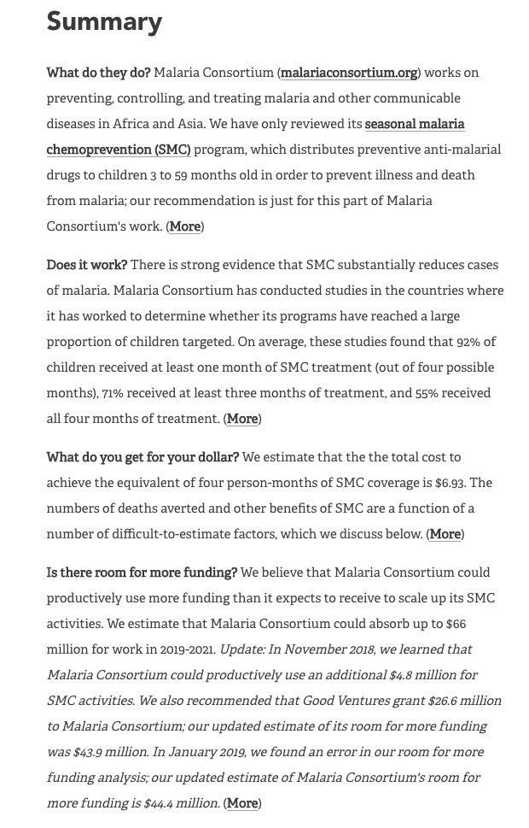

These questions are:

* **What do they do?**
* **Does it work?**
* **What do you get for your dollar?**
* **Is there room for more funding?**

Answer these questions comprehensively and persuasively across your website and you’ll give a potential donor all the rational reasons they need to make a donation.

This will work in tandem with the copy, photographs, and videos that appeal to people on an emotional level. This two-pronged approach will give you the best possible chance of building your brand and converting visitors to your site to donors.

# Marketing channels

## Website suggestions

Your website is one of the most important marketing assets to get right.

A well-designed and properly-optimised website can make a huge difference to your business’s success. And the homepage of any site is the most important page.

As you were looking for guidance on your upcoming website redesign, we’ve dedicated this section of the strategy to giving you suggestions on how to take your website forward in the most effective way possible.

With that in mind, here are the elements we feel the most effective homepages all feature:

**What makes a good homepage?**

**1. The design clearly answers "Who I am," "What I do," and/or "What can you (the visitor) do here"**

If you're a well-known brand or company (like Adidas or Amazon) you may be able to get away with not having to describe who you are and what you do; but the reality is, most businesses still need to answer these questions so that each visitor knows they are in the "right place."

If visitors can't identify what it is you do and what your USP is within seconds, they won't stick around long.

**2. The design resonates with the target audience**

A homepage needs to be narrowly focused -- speaking to the right people in their language. The best homepages avoid "corporate gobbledygook" and eliminate the fluff.

**3. The design communicates a compelling value proposition**

When a visitor arrives on your homepage, it needs to compel them to stick around. The homepage is the best place to nail your value proposition so that prospects choose to stay on your website and not navigate to your competitors'.

**4. The design includes calls-to-action (CTAs)**

Every effective homepage uses primary and secondary calls-to-action to direct visitors to the next logical step. Examples include "Donate now," "Fundraise with us," or "Learn More."

Remember, the goal of the homepage is to compel visitors to dig deeper into your website and move them further down the sales funnel. CTAs tell them what to do next so they don't get overwhelmed or lost. More importantly, CTAs turn your homepage into a sales or lead-generation engine, and not just brochure-wear.

**5. The design includes social proof**

Social proof is one of the most effective influencers, and the most effective homepages call on it to instantly build trust with new visitors – even if it’s the first their hearing of the brand.

Social proof is anything that shows how many other people or businesses just like your target customer are using your product or service.

To help illustrate how these principles can best be applied to a charity website such as your own, we’ll review the homepages of some best-in-class websites for charities around the world.

### Charity: Water

[The Charity: Water website](https://uk.charitywater.org/) is an excellent example of a charity website and one we recommend you emulate with your new website.

We’ll break each section down and explain why:



The homepage begins with an aspirational image and message encouraging people to fundraise for the charity.

Looking at this messaging, it would appear that Charity: Water’s target audience is young men who are driven to do things like “climb a mountain” and “swim the channel”. This copy and imagery appeals to this target audience, which is what makes it effective.

The call to action (CTA) here is to start a fundraising campaign, which they will want to push from a commercial point of view. You will need to decide internally what the main action you’d like to push across your site, but this should sit right at the top of your homepage, just as it does here.

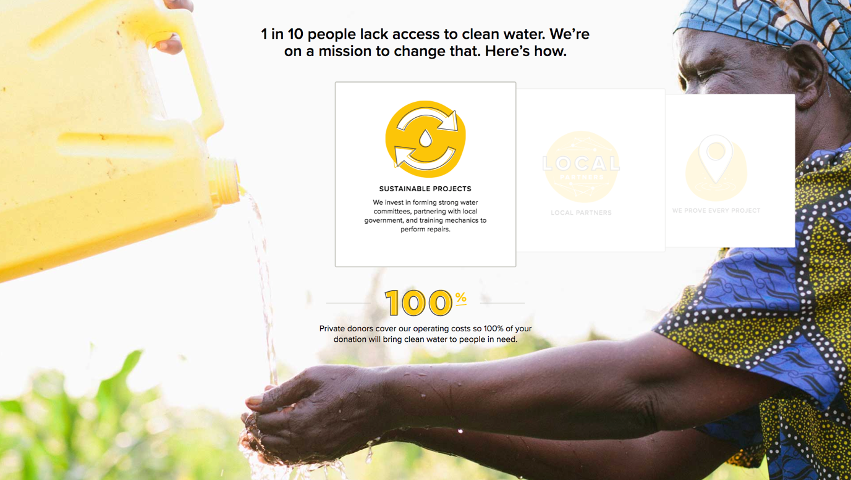

This section is an exceptionally effective way of ticking many of the boxes that a charity website should.

Firstly, it connects Charity: Water’s cause to a larger mission by starting “1 in 10 people lack access to clean water. We’re on a mission to save that”.

While your mission isn’t as big in scale, it still means so much to your local community. A sentence or two that explicitly connects your operations to a mission will give people something aspirational to connect to, which we’ve previously discussed as being crucial.

The colour scheme of this section (and the rest of the homepage) is also happy and aspirational, reinforcing this message.

This section then has a few quick tiles that go into detail about the work that the charity does. This is an essential part of any homepage and is well done here.

This section ends by explaining that because private donors cover 100% of the charity’s operating costs, 100% of the money you donate goes straight to “brining clean water to people in need”. This is an extremely strong selling point, and something we recommend you replicate on your own homepage with a pie chart that shows where each pound donated goes to in your charity.

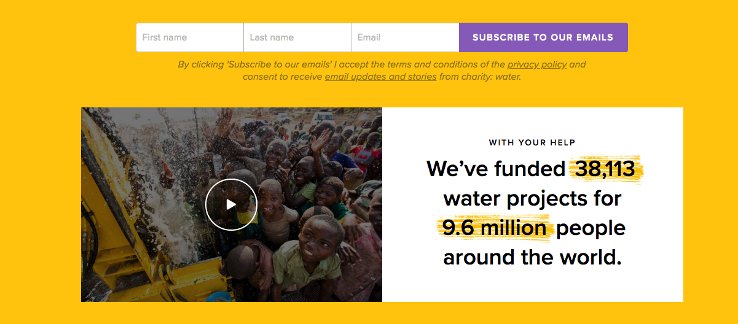

A CTA to subscribe to Charity: Water’s email list starts this section.

Building an email list is an incredibly effective way to directly reach your donors. Post is expensive and often gets ignored, while only a fraction of your followers will ever see your social media posts.

Emails, on the other hand, are much more likely to be viewed compared to other forms of communication and allow you to create a strong bond with your donors.

We feel it would be particularly effective to send monthly emails out to your donors that give them updates and stories from the services you’ve been providing to your patients.

This is a fantastic way of humanising your brand and creating a strong connection between what you do and your donors’ money.

This email sign up box is followed by a very effective explainer video that shows the difference Charity: Water makes. We’ll go into more depth in explainer videos later in this strategy.

This is accompanied by the sentence “With your help we’ve funded 38,113 water projects for 9.6 million people around the world”. Again, linking a donor’s support to the overall mission your charity is tackling like this is an excellent way of selling someone on your charity.

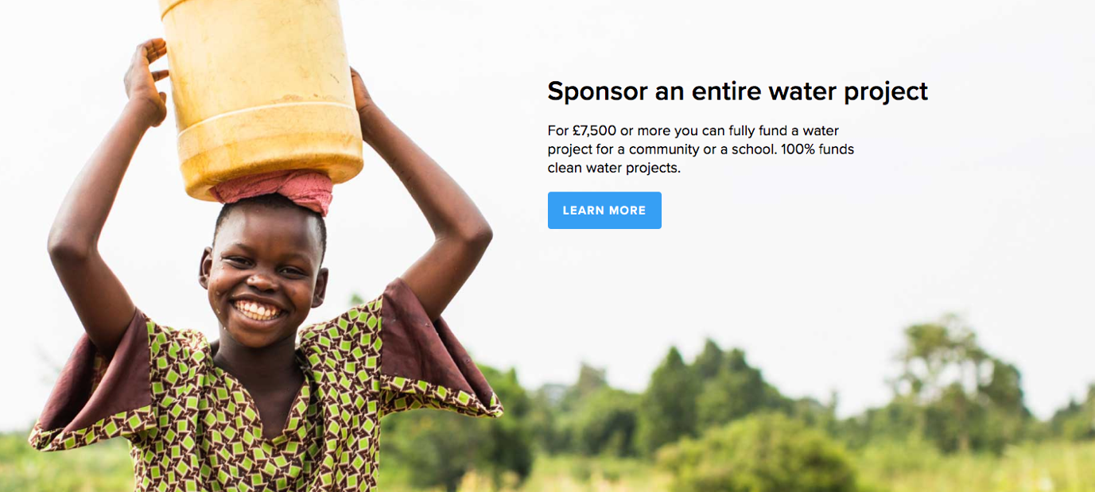

The Charity: Water website ends in another CTA – this time to learn more about how you can sponsor an entire water project for £7,500.

This section is the perfect example of how to introduce how far a certain amount of money could go. In your case, it would be showing that £X funds an entire days’ running costs for your hospice. This links people’s donation to a specific result, which helps them feel more connected to the service they’re supporting (alongside an email newsletter and social pages showing photos and videos of the services you provide).

### Unicef

[The Unicef website](https://www.unicef.org.uk/) is another excellent example of a very effective charity website. It follows a very similar format as the Charity: Water site, which we also recommend you base your website on:



The first section of the site features a video that showcases the work Unicef does in an effective and dynamic way. We have a similar feature at the top of [our own site](https://mmc.agency/), and it’s something we feel is a very effective way of selling a product or service.

We recommend you contact videographers to get a price for having a similar feature at the top of your own site. If it’s within your budget, it’s a very effective way of humanizing your brand.

This section also has a clear and effective strapline and CTA and is highlighted in bright, friendly colours. We recommend your new site incorporates bright and bold colours as well to create a friendly, optimistic feel on your site as well.

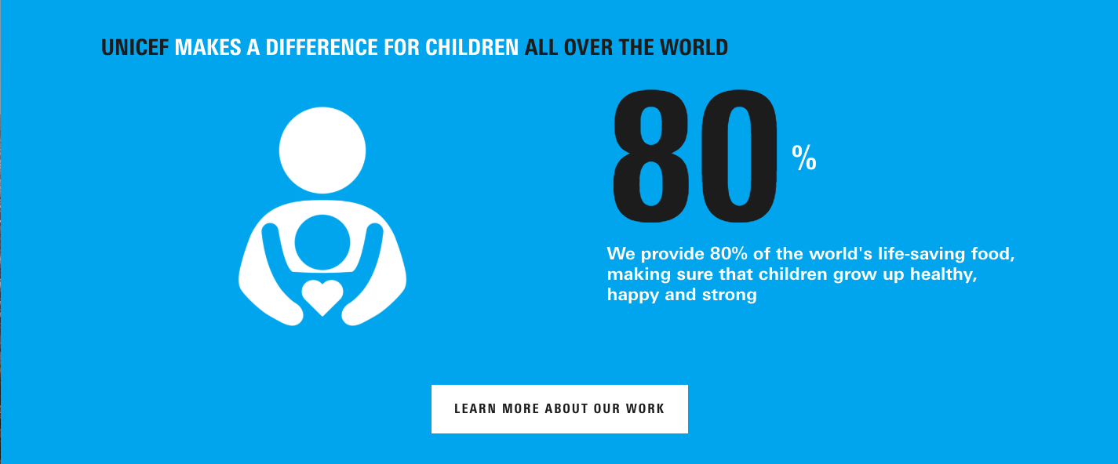

The next section of the Unicef site features the all-important statistics that we’ve previously discussed. This is an essential part of any charities selling point – no one wants to give to an ineffective charity that, in the grand scheme of things, is solving a relatively unimportant problem.

We strongly recommend you follow Unicef and Charity: Water’s lead on this and include statistics that showcase how critical your hospice is to the local community and the difference you make.

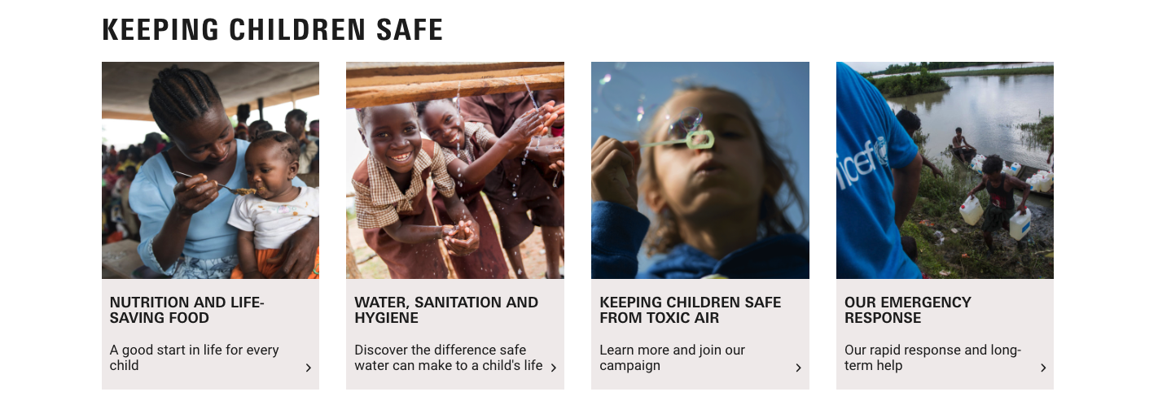

The next section of the site gives more information about the work Unicef does. Given you mentioned that people often don’t realise that your hospice isn’t just “somewhere people go to die”, we strongly recommend you include a similar section on your homepage.

It’s important to note here that the images and copy used in this section are positive and aspirational. As discussed earlier, positive and aspirational images and content are much more effective at selling potential donors on your cause than any attempt to “guilt” them into a donation (whether deliberately or through poorly thought out copy). This is evidenced by both the Charity: Water and Unicef sites, which solely focus on inspiring visitors to donate or fundraise with them.

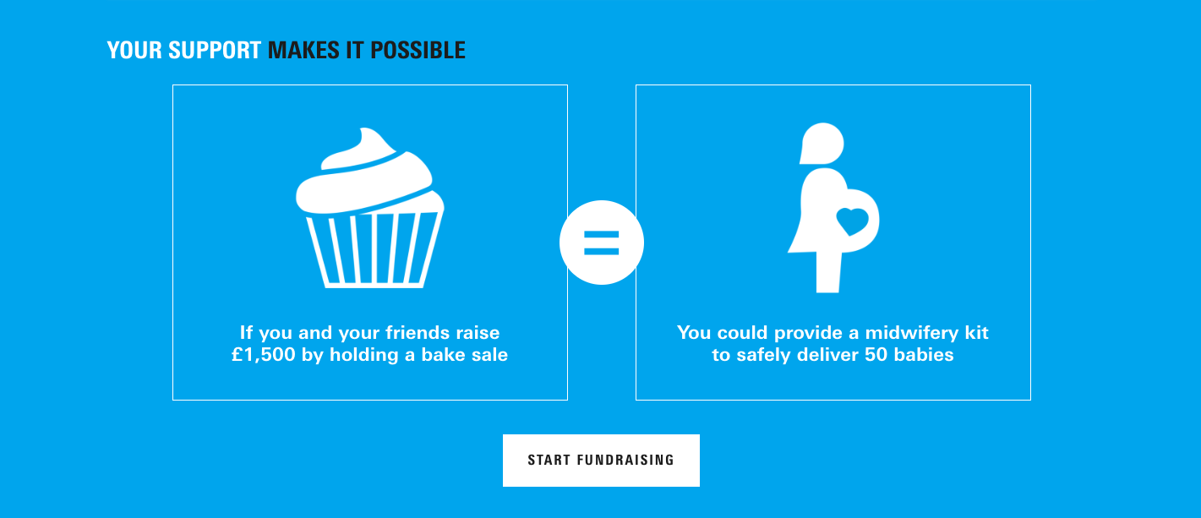

This section is a great way of connecting how much you raise or donate will pay for. As we’ve discussed previously, we feel this is an essential section for any charity’s homepage.

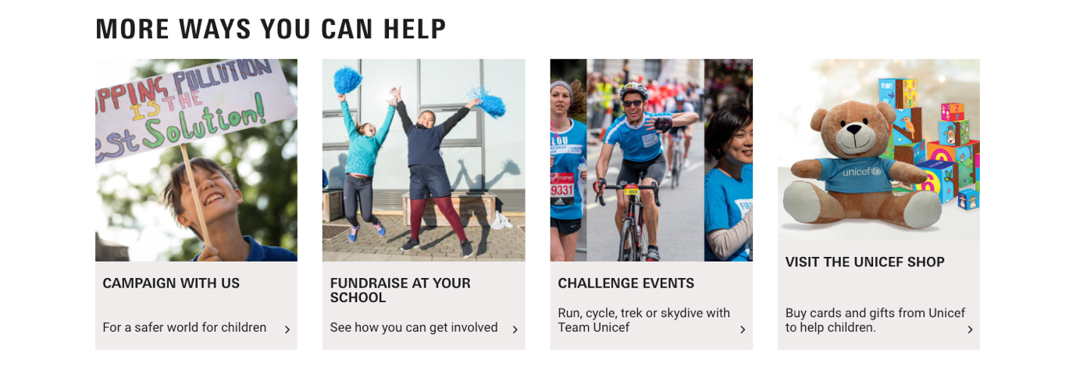

The Unicef homepage ends with a call to action of “More ways you can help”. We feel this might be an effective element to include in your homepage, as it helps make people aware of all the ways they can support you – donating, fundraising, buying from your charity shops, attending your events, and donating in memory.

## Content marketing

Content marketing is an effective way of giving visitors to your site more information about your charity and the work you do. It’s also another great opportunity to humanize your brand by introducing your staff and showing the activities your patients take part in.

Having reviewed your existing news section, we noticed you already consistently post content about upcoming events, people’s fundraising efforts, and the activities that take place at your hospice.

This is great content, but one area we feel you’re missing out on is video. Given the work that you do, video content will be the perfect way to showcase the events going on at the hospice.

It will also be the perfect way to humanise your staff, if they’re comfortable in front of a camera.

## Explainer video

An explainer video is one of the most effective ways of quickly showing visitors to your site what it is that you do and why you do it.

We feel it will be a particularly effective way of explaining all the different services you provide to your patients and the different people you can help.

It’s also a great way of humanising your staff by getting them on camera, as well as dropping in some effective statistics about how effectively you solve the issue you’re tackling as a charity.

We recommend you contact a few local videography agencies for their thoughts on how you can best represent your charity through an explainer video.

We recommend the video prominently features the activities you run for your patients. It could be effective to have the video narrated by members of your staff, and it will be especially effective to include a short testimonial or two from someone about how your hospice has helped changed one of their loved one’s life.

In our experience, your explainer video should come in at around a minute and a half – any longer and people lose interest.

Once you have this explainer video, you can use it on the homepage of your website, across your social pages, and whenever someone would like to know more about the hospice.

## PPC/paid social advertising

Digital advertising is a very effective way of getting your brand in front of people who otherwise wouldn’t have heard of you.

Given that you’re based in Durham and Chester-Le-Street, your “target audience” of donors is restricted by geography, making it very effective to target them.

We feel that social media advertising – especially through Facebook – will have a significant impact here. You can target extremely specific demographics through this platform with both general advertisements to raise brand awareness and specific adverts for upcoming events.

Having reviewed your social pages (which were excellent), we feel this is the only thing missing from your social media strategy.

If you choose to go down the digital advertising route, we strongly recommend you speak to a specialist freelancer or agency. It’s very easy to spend a lot of money and get no return if you’re inexperienced with Facebook ads, and a professional will be able to get the most from your campaigns.

# 6-month marketing roadmap

## Month 1

Define your target audience

Define your USP

Review the best practice websites we’ve highlighted and consider how to fit those same elements into your own website

## Month 2

Contact web development agencies to get their opinion on which direction to take your site and for prices

Contact photographers and videographers for prices for create new imagery and video for your new website, including an explainer video

Contact a PPC agency about a Facebook advertising campaign

## Months 3-6

Either hire a copywriter to write the script for your explainer video and the copy for your new site or create it in-house

Project manage the web build, photography, and explainer video creation

Begin experimenting with video on your blog

Use the insights from your Facebook advertising campaign to inform the direction of your social media content

Publish your renewed site with its targeted messaging